Corner of Clark and Randolph

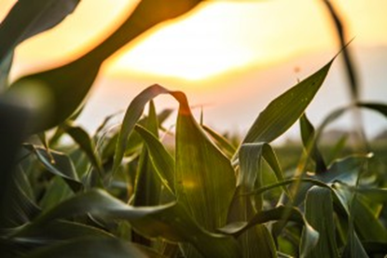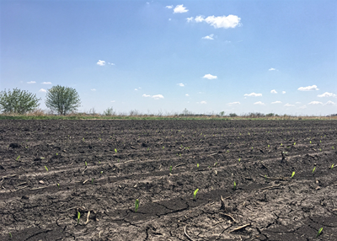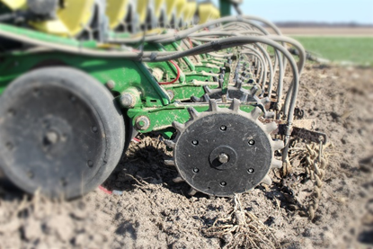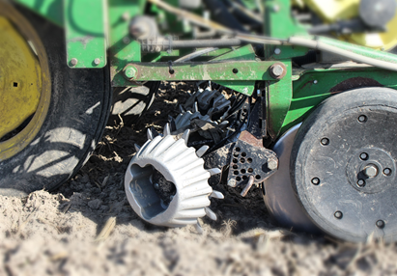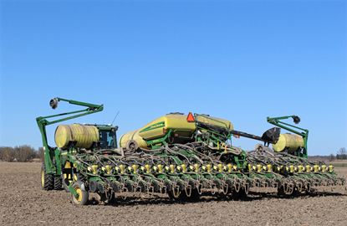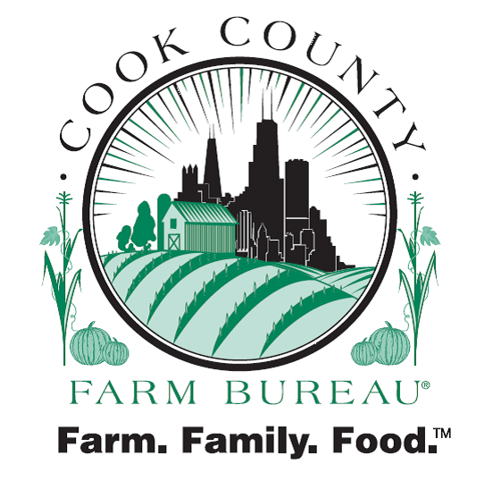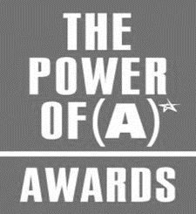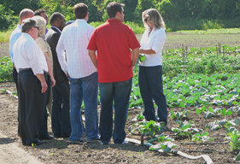

The **corn** in this field is two days post-emergence.

The **closing wheels** close the seed trench behind the seed. The chains level the dirt behind the closing wheels.

A **no-till coulter** breaks up the ground ahead of the **disc opener blades** and **seed tube**, so the seed can reach a well-prepared seed bed. The **disc openers** create the slot for the seed tube to drop the seed in.

A **planter** is a farm implement, usually towed behind a tractor, that sows (plants) seeds in rows. It is connected to the tractor with a drawbar or a three-point hitch. The picture above has a single **seed box** that is filled, and then air pressure blows the seed to the seed boxes. A **seed meter** drops the seed into the seed tube. The **seed tube** then drops the seed into the seed trench.

Images of Cook County Farming

7. Charitable food providers to purchasing domestically produced USDA commodities for distribution to government assisted nutrition program recipients.

8. Illinois Health and Human Services staff contacting government assisted nutrition program recipients’ who request a replacement Electronic Benefits (EBT) card more than twice in a 12-month period.

9. Efforts to increase regional food banks' proportion of state and federal public aid funds for food and nutrition assistance programs.

10. Efforts to increase funding for food banks to cover storage and distribution costs.

We support legislation:

1. Requiring able-bodied recipients to work to be eligible for receipt of government assisted nutrition program benefits. Such work could include training or education programs.

- Continued on Page 2-



Farm Bureau members are actively engaged in conversations about the importance of modernizing government assisted nutrition programs, including Supplemental Nutrition Assistance Programs (SNAP). The draft policy provides:

Government Assisted Nutrition Programs

We support:

1. Government assisted nutrition programs to provide a basic nutrition benefit to need based individuals.

2. Government assisted nutrition programs allotments based on a fair value amount that accounts for the true cost of food, including geographical food price variation and time costs for food preparation.

3. Government assisted nutrition program incentives for purchase of fruits and vegetables.

4. Government assisted nutrition programs that encourages the purchase of food meeting nutrition dietary guidelines.

5. Enabling older program participants and those with disabilities to utilize government assisted nutrition programs benefits for home-delivered groceries.

6. The acceptance of government assisted nutrition program benefits at Community Supported Agriculture (CSAs), farmers markets, online sales, and farmstands.

Cook County Farm Bureau® First-Ever Foods Policy

Policy to Support Government Assisted Nutrition Programs

Cook County Farm Bureau®, a winner of the 2012 Power of A Summit Award, which recognizes the positive impact that associations have on their communities.

Cook County Farm Bureau®, a winner of the 2013 President award and the 2012 President and Liberty Bell awards.

Published

Bi-Monthly

Cook County   
Farm Bureau®

6438 Joliet Road

Countryside, IL

60525

Phone:

(708) 354-3276

Fax:

(708) 579-6056

www.cookcfb.org

bona@cookcfb.org

June 2018

Vol. VI

In This Issue

|  |  |  |
| --- | --- | --- |
| Farm Bureau Working on Zoning Changes | . . . . . . . . . . . . . | 2 |
| Let’s Talk About the Ag on Your Plate | . . . . . . . . . . . . . | 3 |
| Images of Cook County Farming | . . . . . . . . . . . . . | 4 |

*The Corner of Clark and Randolph is a publication of the Cook County Farm Bureau® Governmental Affairs Department.*

24

Issue

In and Around Cook County Agriculture

Calendar of Events

July

14 Food and Farm Tour, South

19 Breakout Box Family Event, LaGrange

August

16 Farm to Table Dinner

18 Farm Crawl

September

22 Member Picnic

29 Giant Pumpkin Contest

Call (708) 354-3276 for details!

Let’s Talk About the Ag on Your Plate

Why do you use chemicals on your farm? *Answered by Mike Rauch, Cook County Farmer*

‘Nutrition’ Continued from Page 1

We oppose:

1. The use of government assisted nutrition program benefits being used to cover delivery costs for online food purchases.

2. Using Temporary Assistance for Needy Families (TANF) funds for the purchase of alcohol, cigarettes, lotto tickets, and similar items.

Farm Bureau members will officially consider the policy during the August committee meeting. If approved the policy will be submitted to the Illinois Farm Bureau® for consideration by the delegates.

This policy would be the first-ever government assisted nutrition policy considered by Farm Bureau.

Every farm is different. Farms have different soil types. Farms have different weed, insect, and disease pressures. Because of these differences and others, some farmers will choose to use crop protectants and some farmers will chose not to use crop protectants.

Before making any decision, farmers carefully consider soil types, seed traits, and their markets. Farmers also review land grant university studies and new developments in farming to ensure that they are using the safest and best practice on their farm. Before applying any crop protectants, farmers examine their crops for insects, weeds, and disease and only use crop protectants when needed.

The crop protectants of today are extremely precise, effective, and leave virtually no residue. They’re also extensively tested and proven safe by the Food and Drug Administration, US Department of Agriculture, and the US Environmental Protection Agency. Before a farmer can purchase or apply any chemical, they are educated, tested, and certified by the Department of Agriculture.

Cook County Farm Bureau® exists

“To serve all members of the Cook County Farm Bureau® with meaningful and beneficial programs that reflect our agricultural heritage.”

horse riding stables, horse tracks, and carriage barns in Cook County have fewer acres of land than horses.

Midwest farmers use a combination of limited time grazing and supplemental feed (hay, grain, etc.) to maximize the number of animals they can house. Farm Bureau successfully negotiated a change to the ordinance to reduce the lot size requirement and to eliminate the requirement for an owner to have an equal number of acres and horses.

Farm Bureau is working closely with the Chairman of the Building and Zoning Committee, his staff, and Building and Zoning staff to negotiate the changes and to mitigate the impact on Cook County agriculture.



Farm Bureau Working on Zoning Changes

Amendment to Lessen Impact on the Horse and Livestock Community

Farm Bureau actively engaged with Cook County Commissioners and staff to minimize the impact of proposed zoning changes on Cook County agriculture.

The amendment, which was approved in June, provides:

* Reasonable minimum lot sizes for individuals interested in keeping livestock or horses.
* Reasonable requirements for apiaries located on smaller residential lots.
* Reasonable minimum requirements for animal enclosures.

In February, Farm Bureau submitted comments regarding minimum lot sizes for the keeping of bees. The proposed ordinance stipulated that bee hives were limited to lots with an area of at least two-acres. This lot minimum along with limits regarding the number of hives was eliminated in the most recent draft of the ordinance.

A subsequent draft provided that livestock and horses could only be kept on lots with a minimum area of three or five-acres respectively and that an acre of space was required for each adult animal. Almost all

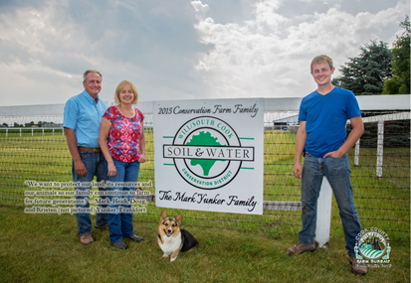

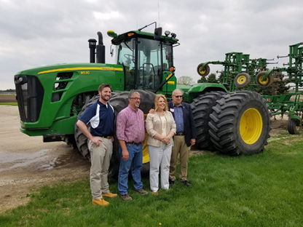

Spring and early summer flowers are “popping up” throughout Cook County. Farm Bureau members are encouraged to send photos of their gardens through Facebook and Twitter using #WhatsYourGardenGrowing.

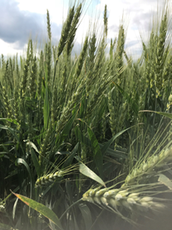

Wheat harvest is likely to begin in earnest this month. Please keep your eyes open for farm equipment moving on Cook County’s roadways. Farm equipment is often difficult to see around, please use extreme caution when passing.

“We want to protect our land, its resources and our animals so our family can continue to farm for future generations.” Yunker Family, Cook County farm family

Cook County Farm Bureau® met with the U.S. Environmental Protection Agency Region 5 Administrator this May to discuss jurisdictional concerns and water issues.

Pictured left to right is: Alec Messina, Director of Illinois EPA; Steve Pitstick, Kane County farmer; Cathy Stepp, U.S. EPA Regional Administrator; and Raymond Poe, Director of Agriculture.

The mission of the Governmental Affairs Committee is to surface and develop policy and to provide reliable, accurate, and common-sense information to elected officials and their staffs in order to build a dialogue between the organization and policy makers. The Governmental Affairs Committee serves as a voice for all Cook County Farm Bureau® members.