The Essence of “Grassroots”

Cook County Farm Bureau is an organization of people. Members help the organization achieve great things year after year by volunteering time, energy and talent to create better agriculture in Cook County.

We are blessed to have many excited and enthusiastic volunteers who offer so much to our efforts and we welcome members who want to join in on the fun…

Listed below are a few opportunities:

□ FB ACT
Here's something you already know, every day, politicians and regulators make decisions that impact the way you farm. But here's something you may have overlooked, politics have changed a lot! Don't feel discouraged. You can take back your influence in Washington, Springfield, and even your own backyard with Farm Bureau's FB ACT program.
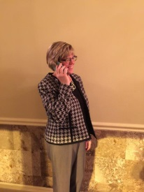
FB ACT (Farm Bureau Agricultural Contact Team) started as a group of men and women who had an interest in the legislative process. That used to work. Today, your voice can easily be drowned out by others speaking out against you.

When you join FB ACT, we ask that you vote and respond to action requests by emailing or calling your elected officials on key agricultural issues.

□ The Farm Corps
An “on call” group of members that we reach out to a few times per year when we need an “extra” set of hands that will bring enthusiasm for agriculture.
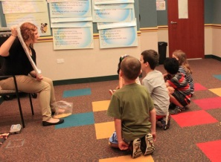
Examples include:
- Working with Ag Literacy programs such as Ag Days for 3rd graders, farm camp for kids and the summer library reading program.
- Working with the Public Relations team on public outreach events such as the Wagner Dairy Breakfast, Food Checkout Day school food delivery and “Ask a Farmer” events.
- Working with our other teams on programs that help members, improve agriculture and expand knowledge about farming.

□ Action Teams
On an annual basis, the CCFB Board of Directors seek members that wish to provide regular leadership assistance and support of programming through our 5 Action Teams listed below.

- Ag Literacy – This group of leaders focuses on the overall ag in the classroom program, teacher education, ag days, farm camp and ag literacy grant programs..
- Public Relations Team – This group of leaders work in the areas of consumer information regarding agriculture through the Speakers Bureau, program outreach, and public communications.
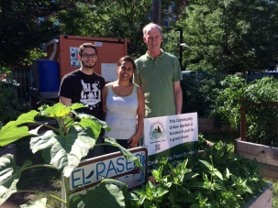
- Commodities & Marketing Team – This group of leaders works on promoting local farm stands, assisting farm markets, development of landowner group programming, equine activities, commodity promotions, agricultural tours, giant pumpkin contest and agri-tourism concepts.
- Member Relations Team – This group of leaders work on benefits, recruitment ideas, member communications, reward programs, membership services, the annual meeting, leadership training, and related activities.
- Governmental Affairs Team – This group of leaders focuses on legislative and local affairs, development and enactment of organizational policy, political involvement, grass roots legislative communications and key issue discussions.
- Young Leaders Team – This group of leaders focuses on becoming closer with the Farm Bureau organization, strengthen leadership abilities, improve agriculture as an industry through programs and activities and provides self-improvement opportunities.

These Teams meet face to face 4 times annually for planning and program development purposes and provide support for many of the programs that are developed through each Team.

If you have interest in any of the above opportunities, please complete the form below and return to the CCFB at your earliest convenience.

Cook County Farm Bureau Involvement Interest Form

Name: _______

Address: ______________

__________________________________________________

Cell Phone: _____________

Home Phone: _____________

E-Mail: ______________

Volunteer interest:
□ FB ACT
Do you wish to receive text message alerts for IFB action requests? □Yes □No
If yes, who is your cell phone provider? _______________________________________________
Do you wish to receive automated/recorded phone messages for IFB request? □Yes □No
If yes, what is your preferred method for contact for action requests? □Cell Phone □Home Phone

□ The Farm Corps—a time and need “on call” group of volunteers

□The CCFB Action Teams (please specify your interest below)
□Ag Literacy □Member Relations Team
□Commodities/Marketing Team □ Governmental Affairs Team
□Public Relations Team □Young Leaders Team

Signature: _________________________________________ Date: _______________________________

Please submit your leadership interest in one of the following ways:
Fax: 708-579-6056
Email: ccfb@cookcfb.org
Website: www.cookcfb.org
Mail: CCFB, 6438 Joliet Road, Countryside, IL 60525

